28 Beaumont Street

Patient Representative Group

Annual Report 2013/14

Practice Profile

28 Beaumont Street is situated in the centre of vibrant Oxford. Our practice area covers the City Centre to the ring road (from Botley to Marston) and several surrounding villages. We have a list size of approximately 4400 with a younger-than-average practice population due to our students. The ethnicity of our patient population is very mixed and representative of the diverse nature of city living.

We are a three partner practice (Drs Stephenson, Borton and Easdale) with three part-time practice nurses. We are pleased to announce that we now also provide a specialist phlebotomist on a Thursday. We have skilled reception and administrative teams to support our work and liaise very closely with our College Nurses at Herford and New College. We hold monthly meetings with our District Nursing colleagues as well as maintaining close links with our Heath Visitors and Midwife (based at the practice on a Wednesday). In the last year we have also begun liaison meetings with the local Community Mental Health Team headed-up by Dr Merson (Consultant Psychiatrist).

We offer routine GP appointments from 0840 to 1710 throughout the week, and in response to feedback from last year’s survey now offer and early morning (0630-0800) and late evening (1830-2000) GP surgeries on a Tuesday. Our reception is open from 0830 until 1830 and telephone lines open at 0800. Appointments can be booked in person, via the telephone and again, in response to patient access suggestions last year, via the internet (through our practice website).

Establishing our Patient Representative Group

We feel it is vital that our patients form the core of our service and we are constantly striving to meet the ever-changing needs of our very varied population. Direct input from patients themselves is vital to this process and can be can provide huge momentum and inspiration for our development. As a result the Patient Participation Group is a key component of improving our care, feeding-back on areas needing more attention and keeping in touch with new needs as they arise.

The practice made significant efforts to ensure representation from all groups of our population. With such a diverse patient list (for the Oxfordshire area) it was important to accurately reflect the practice population in age, ethnicity and with patients who are fit, as well as well as those with long term illness.

We recruited members of the patient representation group in a variety of ways:

- Via our practice website
- Posters in the waiting room
- Posters displayed in the Colleges
- Invited Student Welfare Groups directly through the College Nurses
- Via our new-patient registration forms

We have 14 current members in our group: eight women and six men, whose ages range from 19 to 79. We have representation from our college students, invite the student welfare teams from Hertford and New College, and also those whose ethnic origin is not white British. We are still actively recruiting members to our group, and we will continue to promote this over the coming year (particularly with the new influx of first-year University Students in the autumn). Our PPG was also kindly represented this year at the Oxford City Commissioning Group Area PPG Meeting.

Year 1

We developed and established a Patient Representative Group. Our group created and published the first practice survey.

Year 2

We published an annual report showing how issues raised in the survey had been addressed. Many of our improvements within the practice have resulted directly from patients input from our surveys

- Eg:

- Early morning surgeries
- Text reminders before appointments
- Online-bookable GP appointments
- Downstairs toilet and consulting room
Year 3

We have worked to maintain the high standards from the previous two years as well as to identify areas where more attention is needed and those for future development. As part of this, our PPG has met last August, November and most recently in March of this year. We discussed key issues for the practice and population, provided minutes from the meetings and a notice board area on the ground-floor for PPG-related information.
For a greater insight into the practice performance and areas for our attention over the coming year the PPG compiled a survey. This was chosen during the meeting on 6th November 2013 and was heavily modified from the original (GPAQ) to reduce replication of questions, the overall length (which was felt by members to be excessive) and importantly to allow the option of named and free-text comments at its close. The survey was released on our website as well as there being paper copies provided in the surgery (reception and waiting rooms). The results of the survey were collated and discussed at our most recent PPG meeting (18th March 2014) and an action plan for the coming year was created.

Survey Results 2013/14
Number of Responses: 46
.

About Your Visit to 28 Beaumont Street

How good was the GP at
Q1 Being polite and considerate?
Very good 89%
Good 6%
Satisfactory 2%
Poor 0%
Very poor 0%
Does not apply 2%
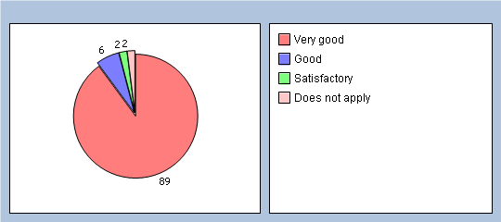

Q2 Listening to you?
Very good 84%
Good 10%
Satisfactory 2%
Poor 0%
Very poor 0%
Does not apply 2%
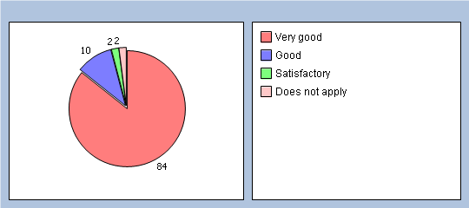

Q3 Giving you enough time?
Very good 69%
Good 21%
Satisfactory 4%
Poor 0%
Very poor 0%
Does not apply 2%
No response 4%
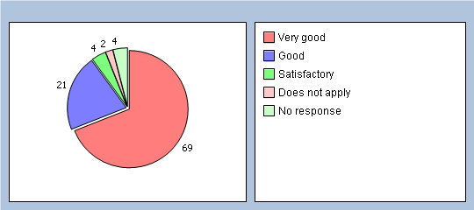

Q4 Assessing your medical condition?
Very good 71%
Good 21%
Satisfactory 4%
Poor 0%
Very poor 0%
Does not apply 2%
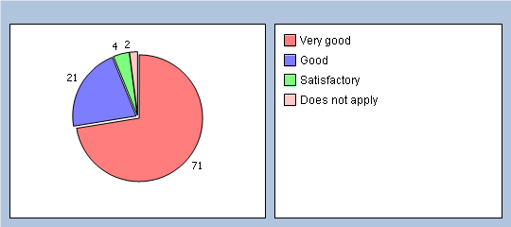

How good was the GP at:
Q5 Explaining your condition and treatment in a way that you could understand?
Very good 80%
Good 8%
Satisfactory 4%
Poor 2% Unfortunately, despite encouragement on the survey to provide a name so
Very poor 0% that specific concerns/experiences could be addressed and rectified in
Does not apply 2% person, the individual in this case did not identify themselves.
No response 4%
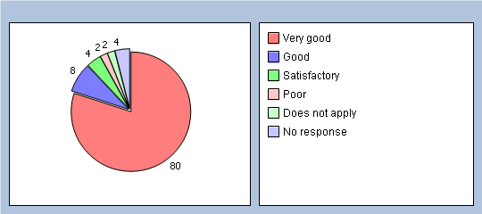

Q6 Involving you in decisions about your care?
Very good 71%
Good 15%
Satisfactory 6%
Poor 0%
Very poor 0%
Does not apply 6%
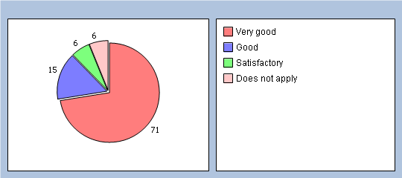

Q7 Providing or arranging treatment for you?
Very good 78%
Good 13%
Satisfactory 2%
Poor 0%
Very poor 0%
Does not apply 6%
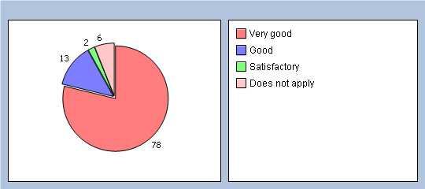

Q8 Did you have confidence that the GP is honest and trustworthy?
Yes, definitely 84%
Yes, to some extent 8%
No, not at all 0%
Don’t know / can’t say 2%
No response 6%
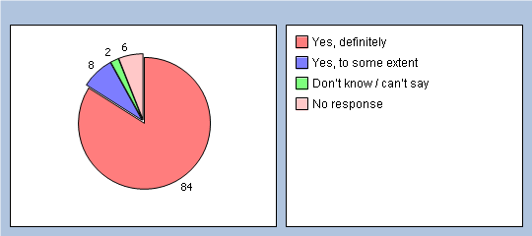

Q9 Did you have confidence that the doctor will keep your information confidential?
Yes, definitely 82%
Yes, to some extent 8%
No, not at all 0%
Don’t know / can’t say 8%
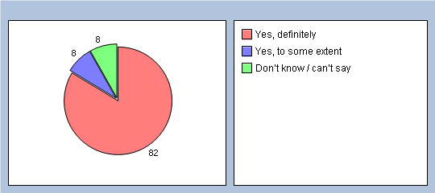

Q10 Would you be completely happy to see this GP again?
Yes 91%
No 2%
No response 7%

Please enter any additional comments/name of GP as desired:

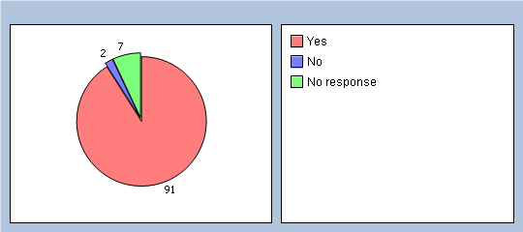

About Receptionists and Appointments
Q11 How helpful do you find the receptionists at 28 Beaumont Street?
Very helpful 76%
Fairly helpful 19%
Not very helpful 0%
Not at all helpful 0%
Don’t know 4%
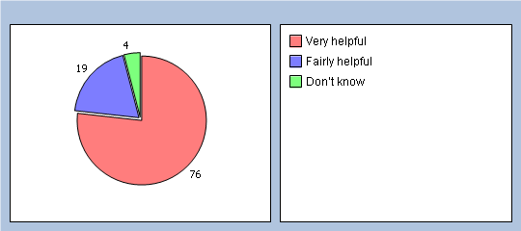

Q12 How easy is it to get through to someone at 28 Beaumont Street on the phone?
Very easy 67%
Fairly easy 26%
Not very easy 2%
Not at all easy 2%
Don’t know 0%
Haven’t tried 2%
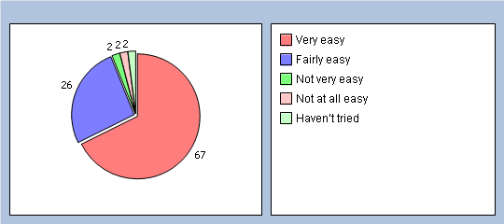

Q13 If you need to see a GP urgently, can you normally get seen on the same day?
Yes 58%
No 6%
Don’t know / never needed to 34%
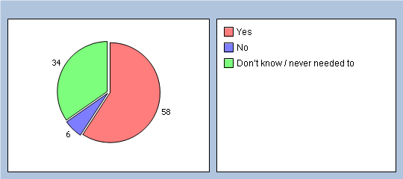

Q14 How easy is it to book ahead at the practice?
Very easy 56%
Fairly easy 30%
Not very easy 4%
Not at all easy 0%
Don’t know 2%
Haven’t tried 4%
No response 4%
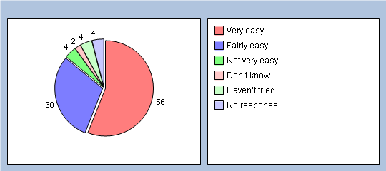

Q15 Which of the following methods do you prefer to use to book appointments at the practice? (please X all boxes that apply)
In person 39%
By phone 84%
Online 17%
Doesn’t apply 2%

Thinking of times when you want to see a PARTICULAR doctor:
Q16 How quickly do you usually get seen?
Same day or next day 8%
2-5 days 56%
6 days or more 8%
I don’t usually need to be seen quickly 6%
Don’t know, never tried 19%
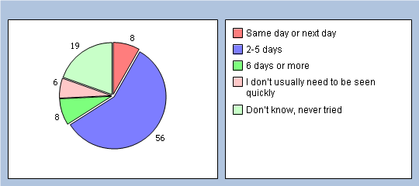

Q17 How do you rate how quickly you were seen?
Excellent 32%
Very good 34%
Good 19%
Satisfactory 4%
Poor 0%
Very poor 0%
Does not apply 6%
No response 5%
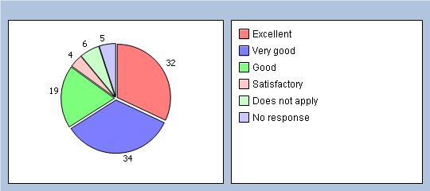

Thinking of times when you are willing to see ANY doctor:

Q18 How quickly do you usually get seen?
Same day or next day 32%
2-5 days 45%
6 days or more 0%
I don’t usually need to be seen quickly 10%
Don’t know, never tried 10%
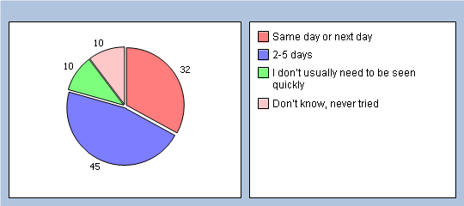

Q19 How do you rate how quickly you were seen?
Excellent 41%
Very good 26%
Good 23%
Satisfactory 2%
Poor 0%
Very poor 0%
Does not apply 6%
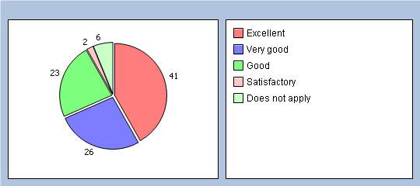

Thinking of your most recent consultation with a doctor or nurse

Q20 How long did you wait for your consultation to start?
Less than 5 minutes 19%
5 – 10 minutes 52%
11 – 20 minutes 19%
21 – 30 minutes 6%
More than 30 minutes 2%
There was no set time for my consultation 0%
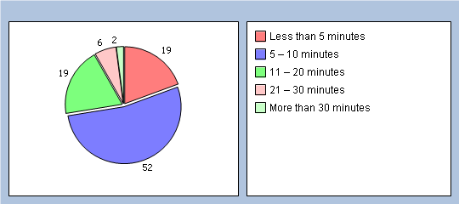

Q21 How do you rate how long you waited?
Excellent 26%
Very good 28%
Good 13%
Satisfactory 28%
Poor 0%
Very poor 2%
Does not apply 2%
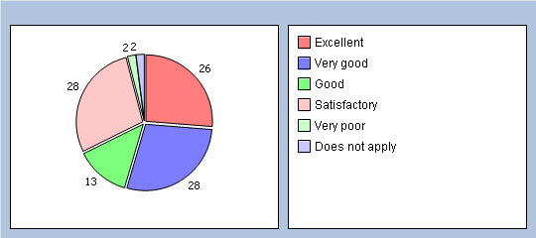

Q22 Is 28 Beaumont Street currently open at times that are convenient to you?
Yes (Go to Q28) 89%
No 8%
Don’t know 0%
No response 3%
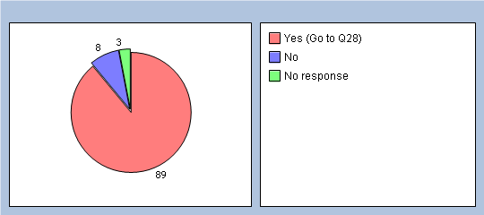

If you haven’t seen a nurse in the last 6 months please go to Q28. How good was the Nurse you last saw at:

Q23 Putting you at ease?
Very good 45%
Good 4%
Satisfactory 0%
Poor 2%
Very poor 0%
Does not apply 0%
No response 49%
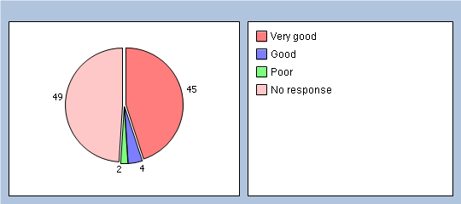

Q24 Giving you enough time?
Very good 43%
Good 6%
Satisfactory 2%
Poor 0%
Very poor 0%
Does not apply 0%
No response 49%
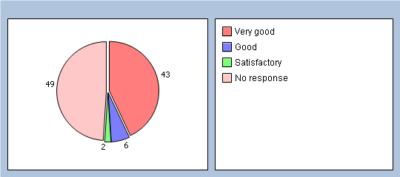

Q25 Listening to you?
Very good 43%
Good 6%
Satisfactory 0%
Poor 2%
Very poor 0%
Does not apply 0%
No response 49%
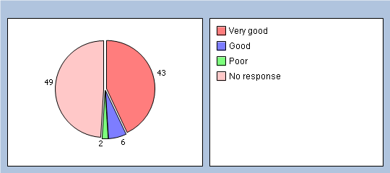

Q26 Providing or arranging treatment for you?
Very good 34%
Good 8%
Satisfactory 0%
Poor 2%
Very poor 0%
Does not apply 6%
No response 50%
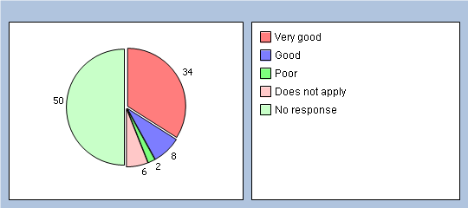

Q27 Would you be completely happy to see this nurse again?
Yes 41%
No 2%
No response 57%
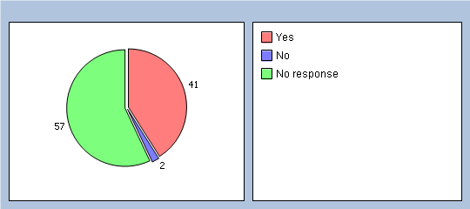

Thinking about the care you get from your doctors and nurses overall, how well does the practice help you to:

Q28 Overall, how would you describe your experience of 28 Beaumont Street?
Excellent 63%
Very good 26%
Good 4%
Satisfactory 4%
Poor 0%
Very poor 0%
No response 3%
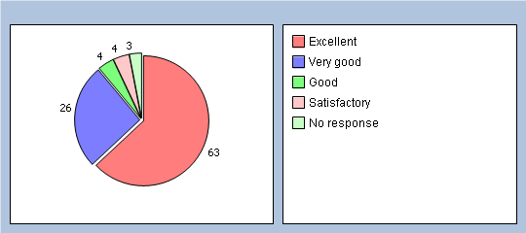

Q29 Would you recommend 28 Beaumont Street to someone who has just moved to Oxford?
Yes, definitely 80%
Yes, probably 13%
No, probably not 2%
No, definitely not 0%
Don’t know 0%
No response 5%
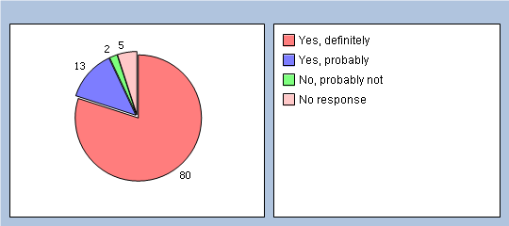

It will help us to understand your answers if you could tell us a little about yourself
Q30 Are you ?
Male 41%
Female 58%
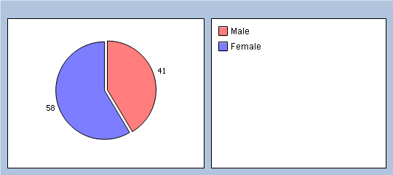
Q31 How old are you?
Under 16 2%
16 to 44 43%
45 to 64 30%
65 to 74 21%
75 or over 2%
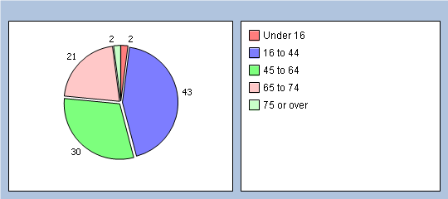

Q32 Do you have a long-standing health condition?
Yes 58% As many of our submissions were made on paper this likely skews the data
No 39% towards those with long-standing conditions/those regularly attending.
Don’t know / can’t say 0%
No response 3%
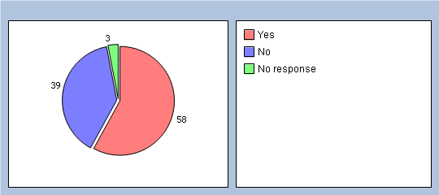

Q33 What is your ethnic group?
White 82% We have decided that in future to expand on this question as
Black or Black British 0% many of our white patients are not white British. Similarly we were
Asian or Asian British 6% only able to provide the questionnaire in English which may have
Mixed 6% dissuaded those with English as a second language.
Chinese 0%
Other ethnic group 2%
No response 4%
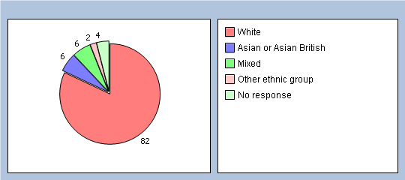

Q34 Which of the following best describes you?
Employed (full or part time, including self-employed) 45% This was somewhat surprising
Unemployed / looking for work 0% given our student population but
At school or in full time education 13% may represent the timing of the
Unable to work due to long term sickness 8% survey being towards the end of
Looking after your home/family 4% the academic (and beyond) term.
Retired from paid work 26%
Other 2%
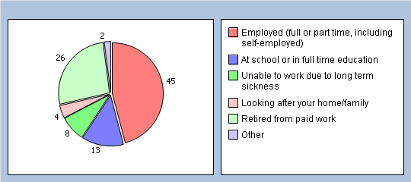

It was felt that on the whole we had received very positive responses. Each of the free text comments (other than those that were purely complimentary) were discussed in turn during the meeting on the 18th.

Verbatim examples (anonymised for this report):

I have been registered here since May 1998 and have always been very happy with the care and time given to me by the GPs, Nurses and Receptionists and would recommend the surgery to others.

I am unsure what will happen to confidentiality once the “care data” plan starts. Will details find their way to insurance companies/big pharmacy etc? Perhaps the surgery could issue some clarification about this to help and decide whether to opt out or not?

Generally wonderful, though sometimes mix-ups on repeats are a nuisance. I hate the electronic sign-in system.

I have been with 28 Beaumont St and before the surgery split/moved from 27 Beaumont ST all my life. I have always managed to get an appointment when needed. Hearing friends say they cannot see a doctor at their surgery until next week or even longer makes me realise how lucky I have always been. Keep up the brilliant work. Also I would like to say how good the receptionists are. I was sat waiting on the ground-floor surgery a few weeks ago and heard a patient come and shout abuse at them and it made me wonder home many times they have to put up with that sort of treatment but the receptionist took it all in her stride. Well done.

Specific Issues Raised/Possible Action Plans:

One recurrent issue was providing access to nursing appointments online (GP appointments are already bookable directly in this way): we have been addressing this with the support of the PPG since November and we have also recently employed a Phlebotomist which should make bookings easier (as a these appointments are a single ‘model/variety’ rather than needing to cover the variety of appointment types provided by our nurses.

A priority for many of our patients (we had seven patients mention this on our survey) was care.data and confidentiality. We have been informed that this has now been delayed until the autumn to give the public more time to familiarise themselves with exactly what will be happening. We have information on our practice website (an FAQ), reception and on practice the noticeboards.

One patient mentioned that although they were impressed by the structural improvements to the surgery they felt that the ramp for disabled access could be more practical. This was discussed at the last PPG group meeting and we will be meeting with the college who own the building to take the two proposed suggestions further (concrete in-filling or decking).

The possibility of email access for advice was raised- the present members of the PPG could see potential benefits with this concept but there were significant concerns regarding the security of emails containing confidential information outside NHS accounts. Similarly it was felt there were significant issues in the difficulty in GPs responding to complex queries- in part due to the lack of verbal and non-verbal feedback that is a key part of face-to-face and telephone conversations, but also the possibility of reading a message in several different ways and in so doing missing the ability to clarify important elements/intent.

The opening times of the Practice were mentioned and the present PPG members felt there was adequate access Monday to Friday (with the ongoing early morning clinic and evening clinics once a week being praised as well as the recent move to starting the routine morning surgeries at 0840hrs). Weekend opening was not felt to be strictly necessary (although obviously desirable in ‘essence’) as it would likely (given the fact that individual GPs would not be working every single day of every week) lead to a degree of dilution of named-GP care during the week.

PPG members and survey comments highlighted that the check in screen was not always correct and if a patient needed to be seen on the ground floor this was not automatically noted. The current solution to this is a message sent to the doctors via their PC to inform them that a patient wishes to be seen on ground floor. The practice will make sure that there are notices in the reception entrance informing patients that if they would like to be seen downstairs then to kindly let reception know.

Action Plan:

- Increase uptake of online-bookable GP services and pilot nursing and phlebotomy clinics online.

- Look into rear access solutions to reduce the ramp inclines

- Publisise the care.data FAQ/practice information sources to allow greater informed choice when the system goes live later this year (as well as directing patients towards our opt-out forms as desired).

- Optimise the use of the new electronic sign-in screen whilst ensuring that those who wish to book in in person do not feel pressured to use it/are aware they can still speak directly to reception.

- Continue to develop the PPG and encourage greater representation from the student population and those of non-white-British ethnicity.

- Promote the use of the PPG notice board to highlight local initiatives and not-for-profit services that might benefit the wider patient group.

