Primary Care Networks

Primary Care Networks are a new way for several general practices to collaborate*.* They are intended to help practices:

* to offer more co-ordinated services,
* to provide better ways for patients to access a wider range of health care professionals.

They will also make more use of digital services.

The regulations around Primary Care Networks have been incorporated into the contract that each GP practice has with the NHS.

Each Primary Care Network will cover between 30-50,000 patients. Practices are of different sizes, so the number of practices making up a Primary Care Network will vary. Every network will choose a clinical lead, usually (but not necessarily) a GP.

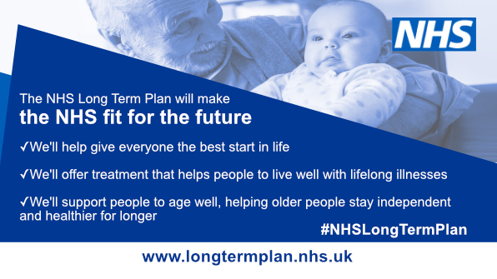

**Why are they being set-up?**

In January 2019 NHS England published a 10-year plan for the NHS. It is designed to tackle 3 key issues. These are:

1) Limits to the amount of funding

2) Shortages of clinical staff, especially GPs

3) Growing pressures from an increasing and ageing population.

Practices will work together and will, with other health services providers make patient care more co-ordinated and easier to access, whilst making the GP workload sustainable.

**What is planned for the next few years?**

Once the networks are up and running funding for additional types of health professionals will be made available. From 2020 this will include Physiotherapists and Physician Associates (a new clinical role) and from 2021 Community Paramedics.

The NHS Long Term Plan also outlines some specific areas on which networks will be asked to focus. In 2020 they will be asked to work as a network on providing improved services to care homes, better early cancer diagnosis, and more co-ordinated care with other community services. From 2021 they will focus on tackling the health inequalities in their locality and prevention of cardiovascular (heart) disease.

**What is happening in 2019/20?**

This year is seen as a ‘setting up’ year. By July 2019 practices will have agreed their networks and agreed a clinical lead (Director).

Each Primary Care Network will cover between 30-50,000 patients. Practices are of different sizes, so the number of practices making up a Network will vary.

Each Network will be given funding to recruit a Clinical Pharmacist and a Social Prescribing Linkworker. Some practices already have these professionals working in the surgery, but these services will now be available in all practices. (See overleaf).



More information can be found on the NHS England website.

**How can patients have a say in any planned changes?**

Networks should involve their patients. It will be for each Network to decide how to work with you*.* For the time being you should be able to get more information through your Patient Participation Group. Every practice has to have a Patient Participation Group. Most practices have details about these groups on their website. The practice manager should also be able to tell you about how your group operates.

**How will these changes affect you?**

You may not notice much change during 2019, especially in practices that already provide clinical pharmacist and/or social prescribing services. However, as practices get used to working together some services and practice staff may be shared and you may find that there may be changes to the types of services that are available to you and where they happen.

**How can I find out more about my local Primary Care Network?**

More information about Primary Care Networks in Oxfordshire can be found on the Oxfordshire Clinical Commissioning Group website. www.oxfordshireccg.nhs.uk

This document has been produced by Oxford City Patient Participation Group Forum. Version 1, May 2019

*WHAT IS SOCIAL PRESCRIBING?*

Social prescribing is sometimes referred to as community referral. It is a means of helping GPs, nurses and other primary care professionals to refer people to a range of local, non-clinical services.

It aims to help you take greater control of your own health.

Social prescribing schemes can involve a variety of activities which are often provided by voluntary and community sector organisations.

Examples include volunteering, arts activities, group learning, gardening, befriending, cookery, healthy eating advice and a range of sports.

There are many different models for social prescribing, but most involve a link worker or care navigator who works with people to access local sources of support.

*HOW MIGHT A CLINICAL PHARMACIST HELP ME?*

Clinical Pharmacists can help you by

* working with you to make sure you take your medicines correctly,
* reviewing any complex medicine regimes,
* triaging and managing common ailments,
* responding to acute medicine requests,
* managing and prescribing for long-term conditions (often in conjunction with your practice nurse)

They also work on prescription management by

* dealing with your medication if you have recently been discharged from hospital
* reviewing any repeat prescriptions
* being the point of contact for all your medicine-related queries.

Pharmacists can also hold minor ailment clinics.